**BrainAmp User Guide V1.0**

Drafted by Steven Pillen of the Cognitive and Cortical Dynamics Laboratory

[stevendpillen@gmail.com](mailto:stevendpillen@gmail.com)

Purpose: This document is intended to be an easy reference for the use of the BrainAmp system. It is not meant to be comprehensive, but it should cover most of the main steps involved in set-up and use of the BrainAmp EEG system.

**HARDWARE SETUP**

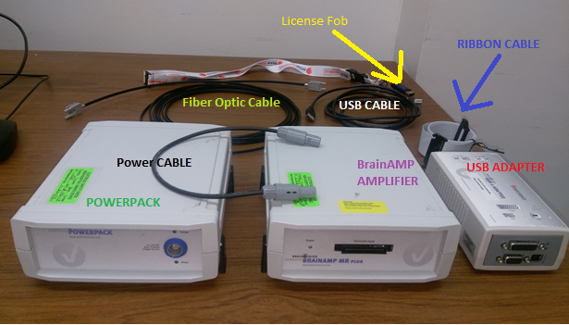

Step 1: Gather all of your parts

This includes:

1. **The License Fob** (Very expensive, do not lose!)
2. **Fiber Optic Cable** (two pronged on each end)
3. **Power Pack** (The left of the 2 rectangular boxes, it has only round power sockets)
4. **BrainAmp Amplifier** (It has a Ribbon Cable socket on the front, and a Fiber Optic slot in back)
5. **USB Adapter** (It has a USB A [the square kind] socket on the front, and Fiber Optic slot in back)
6. **USB Cable** (it has one USB A [the square kind] male end, and one standard USB male end)
7. **Ribbon Cable** (note the white arrows on each end)
8. **Power Cable** (this should socket into the back, rather than the front of the Power Pack seen above)

Step 2: Place the Power Pack and Amplifier within range of where your subject will be seated.

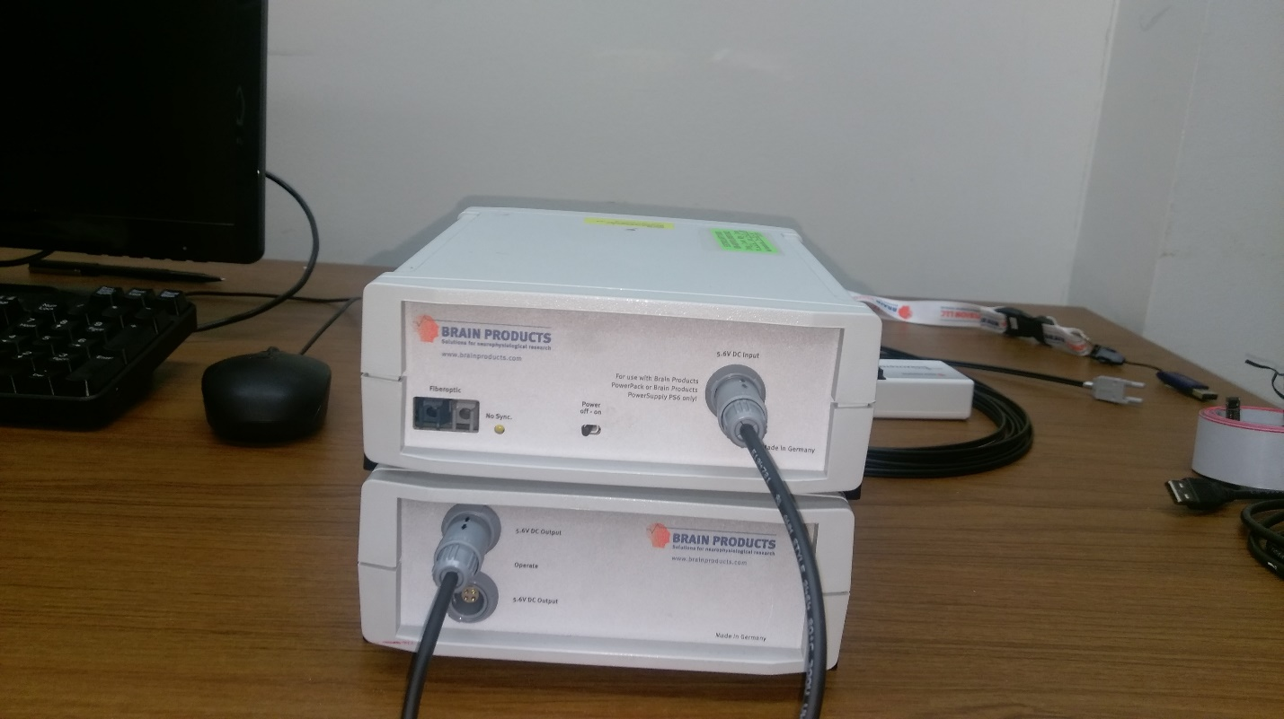

Step 3: Connect the Power Cable between the back of the Power Pack, and the back of the Amplifier.

Step 4: Turn on the Amplifier (Pictured as the top of the stack in the picture above)

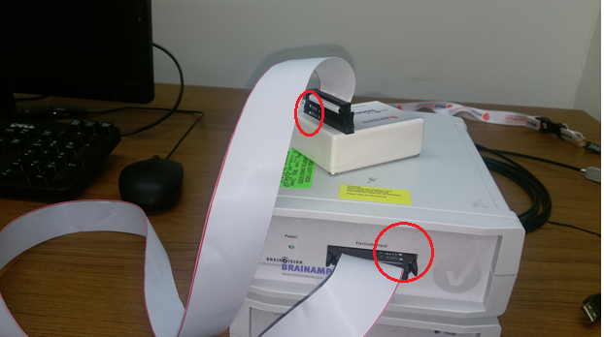

Step 5: Connect the Ribbon Cable between the amplifier and either an EEG headset, or dummy box (above) **MAKE SURE THE WHITE ARROWS OF THE SOCKETS LINE UP, AS SEEN CIRCLED ABOVE.**

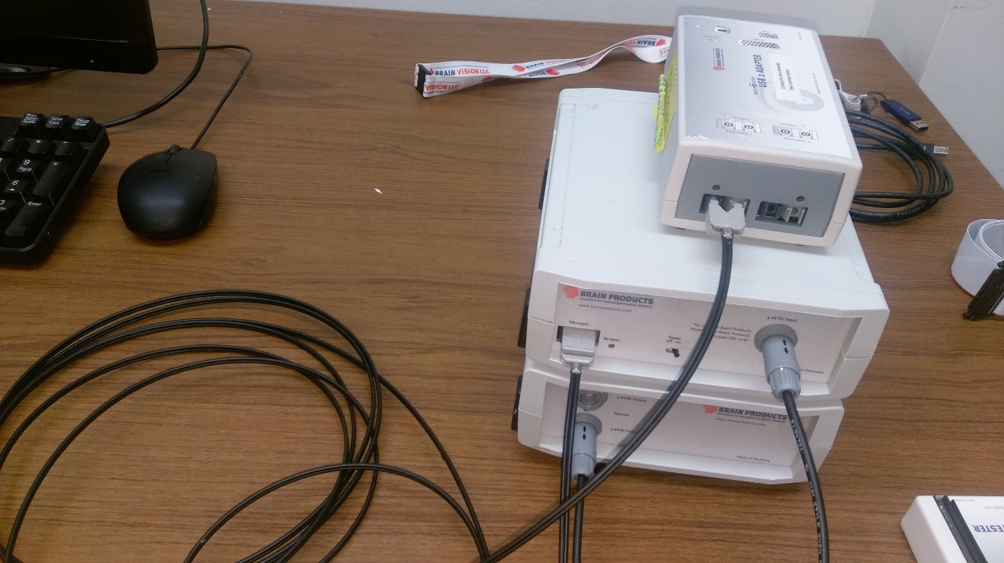

Step 6: Connect the Fiber Optic Cable (the 2 pronged one) between Amplifier and USB Adapter.

**NOTE THAT IT IS PLUGGED INTO THE “FIBEROPTIC 1” SLOT OF THE USB ADAPTER:**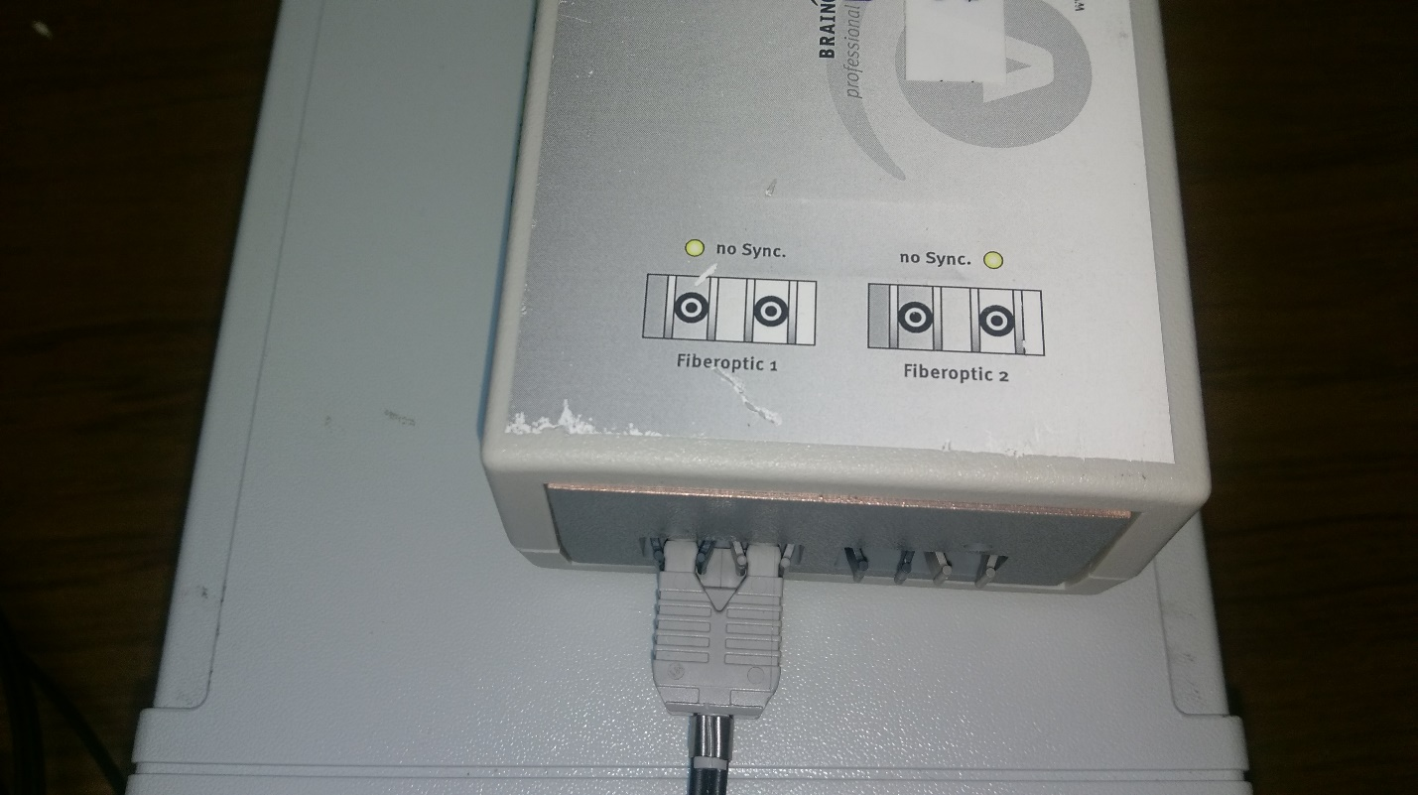

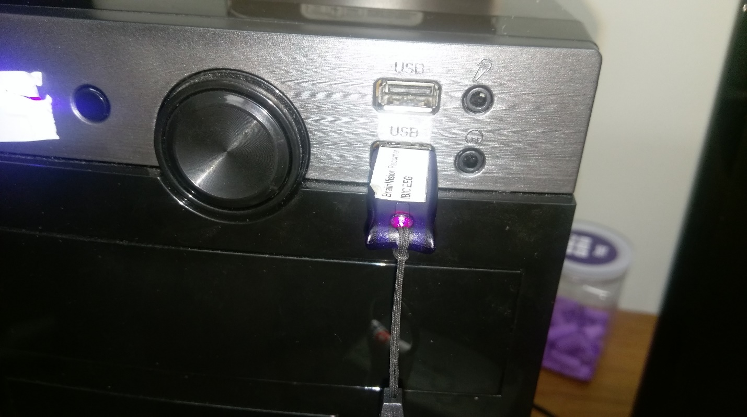

Step 7: Plug in the License Fob (it is probably the most expensive of these items. Be careful not to lose or damage it!)

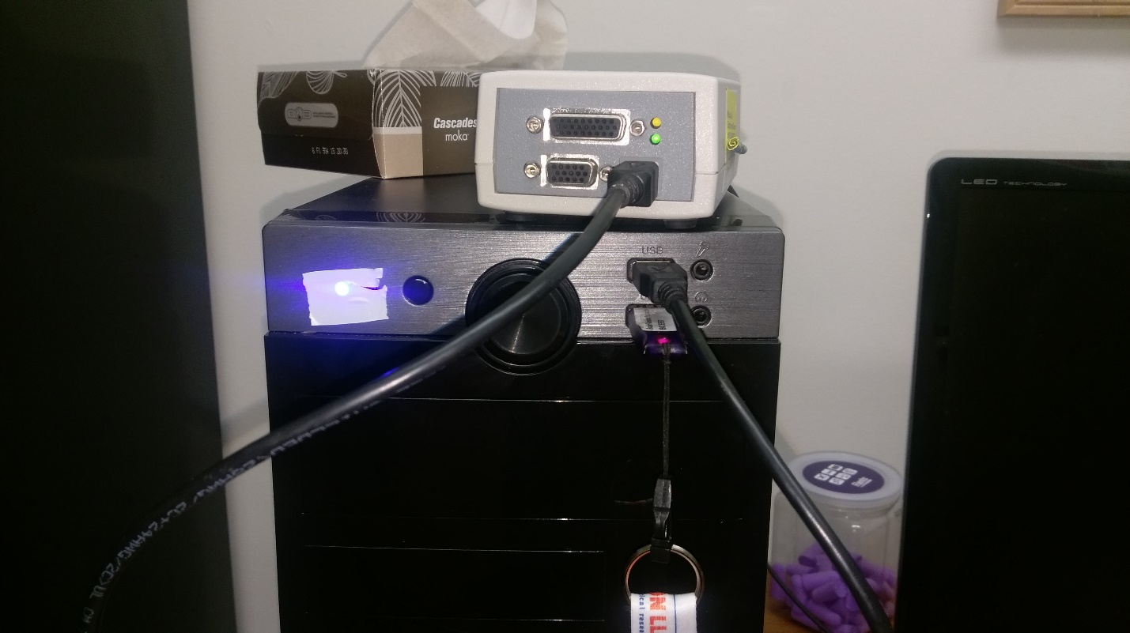

Step 8: Connect the USB A end of the USB cable to the Adapter, and the Standard end to the computer.



Step 9: Open BrainVision Analyzer, which has the green logo seen above.  
  
  
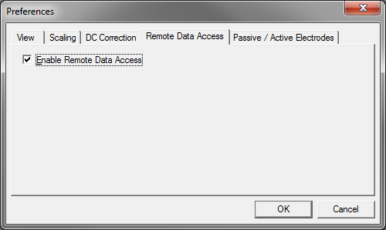  
  
Step 10: Under Configuration>Preferences, make sure Remote Data Access is permitted, as seen above. This is vital for all software external to the BrainVision Recorder that you want to receive the data.

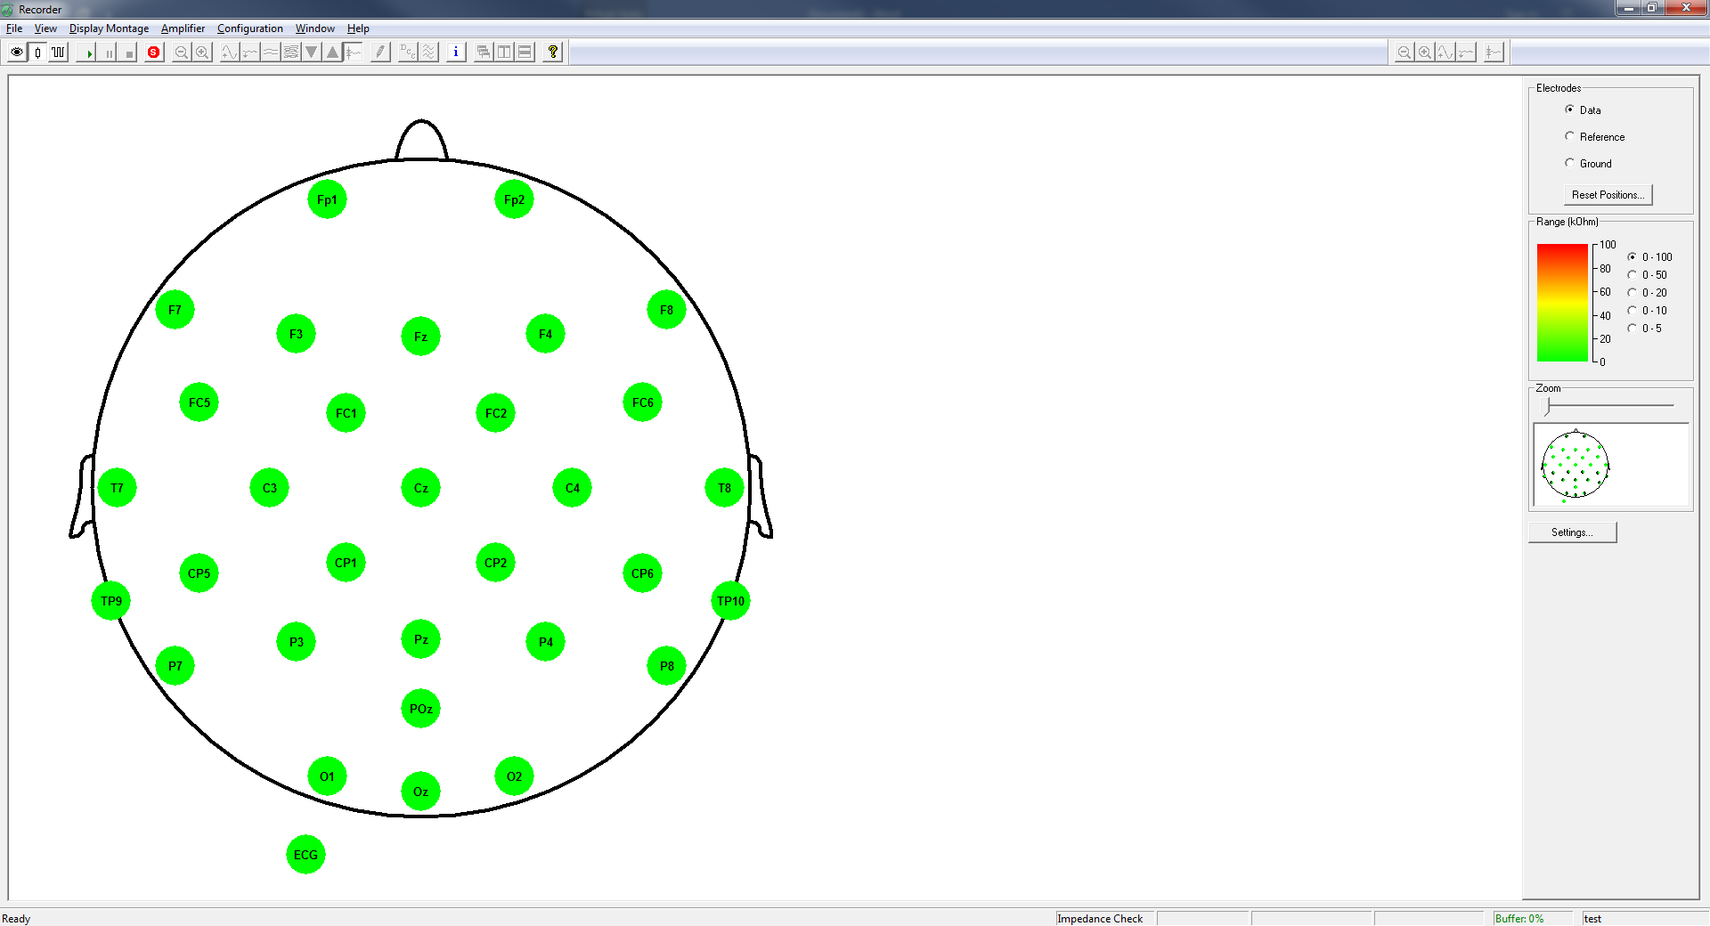

Step 11: Click the “Resistor” symbol, second from the left below the File menu. This shows impedances.

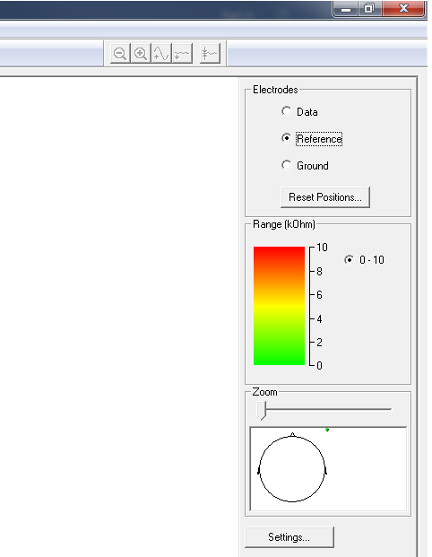

Step 12: Select the Reference and Ground Electrodes in the upper right corner, and adjust them to acceptable values (anything below 10K Ohm) first. **USE ONLY ABRALYTE GEL.**

**NOTE: Impedance numbers can be checked by hovering the mouse over the electrode in question. The ToolTip text that will appear should show you the actual impedance of the electrode, rather than merely the color.**

Step 13: After setting the Ground and Reference to good values, work on the rest of the Data Electrodes.

**Note: I strongly recommend setting the Range to 0-20 KOHM after getting gel in all of the sockets. You’ll want around 10K again, and this is yellow or better on this scaling.**

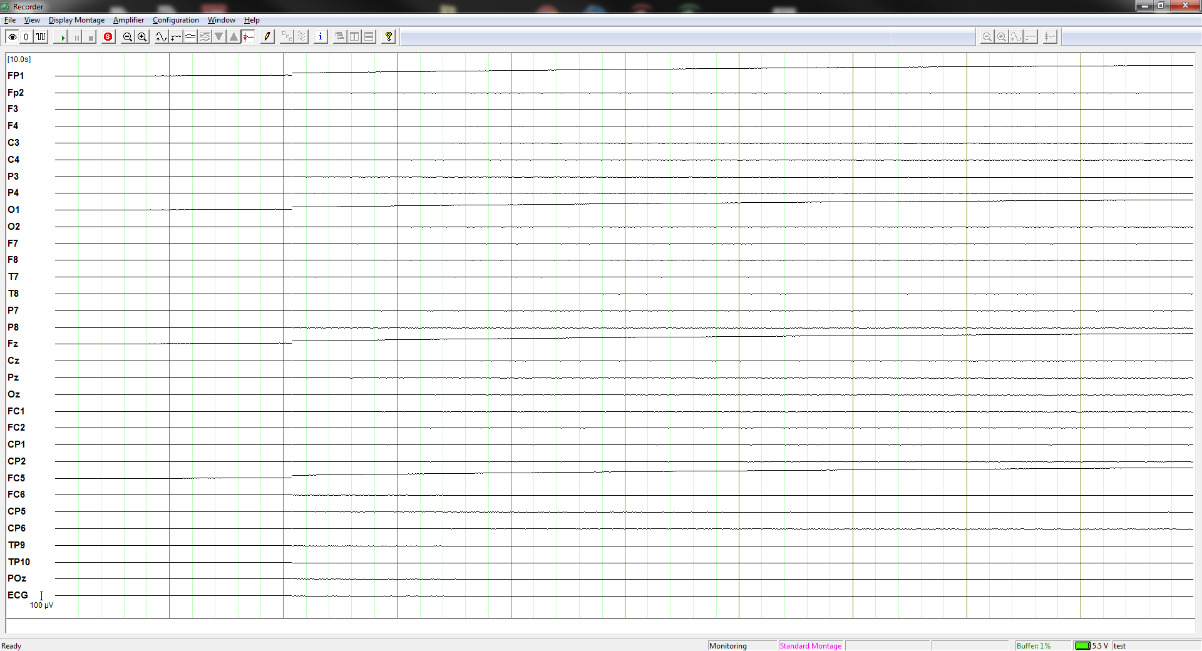

**Step 14: Click the “Eye” symbol in the upper left to switch to the data streaming mode.**

When in this setting, the data is being streamed through the TCP/IP socket. Any software that accesses this through the RDA client will be able to connect as a client to the server that should now be created, and can query the data in real time. **The No Sync LED on the Amplifier and Adapter should turn off.**

**Other Tips:**

When cleaning the headsets after data collection, **NEVER LET WATER INTO THE SIGNAL BOXES!**

**-**If this happens, unscrew the box to open it, drain it as best as you can, then allow it to ventilate.

Never leave an uncleaned headset to be dealt with later! The paste will corrode the electrodes, shortening the useful lifespan of the headset!

When trying to lower impedances on a head, try twisting the wooden end of a cotton applicator in the socket as if trying to drill into the scalp. Take care not to do this too hard however, or else you will cause discomfort!

Stubborn electrodes sometimes benefit from having the socket temporarily lifted while abrading the scalp. This seems to help gel distribute better.

When preparing to begin the experiment, make sure all sockets look full of gel. Even a socket with good impedance but little gel can lose that impedance quality over the course of an hour from drying out!

The “no sync” indicator lights should turn off when data is streaming. If they don’t, something is wrong.

When in doubt, ask Steven for information. He likely has an answer when it comes to these systems.